**CST3990: Undergraduate Individual Project**

**Data Analysis on International Football Results Over the Last 150 Years and Predicting Future Footballing Results Through Machine Learning**

**Coursework 2: Literature Review & Initial Steps**

**Submission: Sunday 14th January 2024, 23:50hrs (End of Week 13)**

**Student ID:M00810926**

**Name: Abdullahi Mohamed**

**CAMPUS: HENDON**

**Data Analysis on International Football Results Over the Last 150 Years and Predicting Future Footballing Results Through Machine Learning**

**Chapter 1: Literature Review**

* 1. **introduction**

The topic is to tackle is a comprehensive 150- year historical analysis of international football examining historical records and predicted results from machine learning techniques. The aim of this is to find patterns within the footballing data and predict results, focus on the historical trend, and produce predictive modelling. The concept of the literature is to highlight the growing data availability and new developments in football analytics. This study displays the information and developing approaches as it tries to conclude the justification of the data sources. While acknowledging the constraints of comprehensive research, this analysis defines the scope and limitations of research forming an analytical and critical assessment of internal football data analysis and predictive modelling whilst setting up boundaries for this investigation. This introduction acts as a guideline, directing an exploration of past data, analytical patterns and forecasting results and finding techniques to enhance the football industry.

* 1. **Relevant Literature**

**Machine Learning**

To predict football match results, Baboota & Kaur (2019) sets the groundwork by combining several variables, including goals per game, minutes played and team budget analysis. Their thesis focuses on the value of team strategy and team dynamics and the financial stability of teams. Their approach lacks in depth player focused analysis advocating that they may have overlooked the influence a singular player can impact the outcome of matches. In comparison to, Rodrigues & Pinto (2022) its tailors to player- specific attribute and past match statistics, their premise highlighted the importance of individual player contributions, offering a shift from team to player analysis. However, their methodology is very narrow and potentially overlooking broader team dynamics that can influence match outcomes. Che Mohamad Firdaus Che Mohd Rosli et al. (2018) displayed a comparative study that examines the reliability and adaptability of data mining approaches, such as decision trees and Bayesian networks. The research paper focuses on analysing with different approaches to forecast outcomes and uses real life football scenario. Differently, Pantzalis & Tjortjis (2020) uses past data and advance statistics to predict other for team performance included refer to whether a team is going to have a better chance or not next season. Furthermore, the research paper takes on statistical categories that separates players into ability, the experimental results are based on data available of the beginning season which highlights the effectiveness of results. Alam & Almulla (2020) uses machine learning classification frameworks to investigate developing a relationship between player performance and match results. Ther theory highlighted the importance role that individual players determine the outcome of the results. The approach they have chosen has overlooked the importance of team factors such as injured players that results to loses and how it affects the player performance. Stubinger, Mangold and Koll (2019) investigated football prediction and found significant returns, the research paper emphasis on the potential financial rewards from targeting specific betting strategies. Meanwhile, the literature review does not take into variables such as home advantages into footballing results. The studies above are all machine learning related to which they all collectively focus on the predictive analysis and offering valuable insights to stakeholders and narrowing certain aspects to achieve a prediction. A lot of complexity involves in predicting match outcomes, displaying the necessity of a balanced approach that incorporates both team and player contributions to the results.

**Data visualization**

Data visualization is pivotal part of footballing performance analysis as it provides a detailed understanding of the dynamic of games. Gásquez & Royuela (2016) decided to analyse team performances by concentrating on goals scored and displaying it. Exploring differences between team dynamics and visualizing to insight managers, betting’s companies, and fan engagement. Mohamad (2023) instead focuses on how much statistics affect team performance using data visualization tool. The purpose of this study was to determine whether match statistics influence team victories, the concept is to link performance indicators to real world match results, however its necessary to address wider ranges of team successes for examples data visualized the key formation to winning match helps provide a further understanding of performance enhancement. Furthermore, Sainan (2023) explores sports data visualization with an emphasis on degree cardinality, the purpose the research paper is to visualize and present the playing pattern throughout the game and a focused approach found in football games. On the other hand, neglection of direction can lead to a lacklustre analysis and leaves gaps in knowledge on the implications of the team success. Elkins (2017) moves the emphasis to real-world uses, using data analytics techniques to improve football performance. The idea is to give coaches play probabilities that are based on data analytics to enhance the skillset of coaches understand what the common patterns within the sports are. Although the study has immediate application and provides valuable insights for coaches, its limitation when defining the scope of the project may prevent a more comprehensive examination of all factors that influence performance in international football such the availability of players and home advantage. These studies all significantly focus on data visualization within football performance, overlooking a broader spectrum of factors that lead to team victories. However, it provides a comprehensive approach that bridges statistical insights with a practical implication and a more robust understanding of how data visualization can truly enhance football performance analysis and contribute to team victories.

**Data Science**

Mansoor Alam (2020), the paper presents a data science approach to minimize the time taken in team selections. Using Power BI and Python Pandas to statistical analysis of player performance based on abilities and skills for players can demonstrate and improve managers to select players and help provide knowledgeable data for stakeholders. However, this literature review focuses on the business side of football but the main interest in sports is internal, the abstract should include fan engagement and management strategies as they directly enhance the sport. The reason being is that internal factors of football are a major responsibility to the success of the sports so that it is important to acknowledge them as your primary or secondary target audience when documenting a research project. Poojan Thakkar & Manan Shah (2021) literature review aims and delves into the impact of data and the influences of data science on the focus being football and seeks to advance and transform the sports. Also, the research paper highlights changes in sports and examines the effects and displays how different strategies, tactics, and overall approach to playing a match can affect. In addition, the competitive edge to gain an advantage over opponents highlights how useful insights can lead to a quality understanding of football. The review also extends into the political and economic state and how it affects various aspects within and beyond sports. On the other hand, the research paper is vague because it generalizes a lot of important topics that need detailing, for example the project can be formulated better if there was a direct aim of the project rather than overview because of the complexity of each topic and it leaves the reader with little understanding of football analytics.

**Resilience of the team/player’s study**

Miguel-Angel Gomez (2020) focuses on soccer teams performances in close game scenarios over various match-status intervals from seventeen Spanish professional league games. There is a notable number of dynamics in football, and each can affect the winning team’s play, particularly in the final third of the match. For example, the losing clubs in ball possession of all parts of game are more likely to lose the match. The goals of this research paper are to understand the resiliency of players and managers and how the results can interpret what scenario are likely to lead players to perform better whether scoring first or scoring later it covers all aspects game development. Differently the review of this topic still lacks direction and certainty because no matter what order of sequence of a game, there are more factors such as the weather and players fitness that decide the game.

**Recommendations to Project**

The organised approach to the current research is presented in this overview of the literature review to which a detailed summary of the topic has been presented, however for this project there will be an element of originality as it will review how players affects matches, how hosting big tournaments affects a nation's success rate, and how long friendly matches affect team performances—all while incorporating machine learning and data visualisation techniques. A more detailed understanding of football through data analysis will be presented and an analysis on different decades can hinder results as players retire or regress, therefore there will be a significant analysing between time and how different teams prevail depending on the national team.

**Conclusion**

To conclude this literature review consists of machine learning data visualization and scientific projects that provide a detailed understanding of football analysis to a certain extent. The analysis of the body of research in football analytics demonstrates the predictive power of machine learning and how it could benefit necessary stakeholders such as manager and betting agencies to predict the correct winner from the code. In addition, displaying the data in a dashboard helps create a visual picture of football and how it can benefit fan engagement because the can see the complex patterns of data simplified into bar charts and line graphs allows for non-technical stakeholders understand it. To improve the conversation, further study should go into the unexplored areas mentioned to offer a thorough comprehension of the complex dynamics of football that this project will include and is going to be beyond prediction models and visualisation strategies.

**Chapter 2: Initial Steps**

* 1. **Overview**

In this chapter the project will focus on the first stages of date cleaning and preparation on Excel to which three sizeable datasets will be analyzed and data cleaned for it to be data explore. This will include a dataset on the results of over 45,000 rows of data to be analyzed, all the international results and those matches decided by penalties. When working with datasets, data cleansing is crucial for several reasons, particularly prior to any analysis or exploration as it contributes to accuracy by correcting mistakes, discrepancies, or missing values in the data. For trustworthy judgements and decisions to be made based on the information given, accuracy is essential. Additionally, data cleaning makes the dataset easier to read and understand. Formats are standardized, duplication is eliminated, and outliers are addressed to make the information more arranged and simpler for the average reader to understand. By cleaning the data, you can make sure that any insights you get from it are well-founded and avoid biased or false information that could distort your findings.

**2.2 Excel**

Results Dataset

**1) remove duplicates**

No duplicates rows provide originality and more accurate findings.

**2) Change source type**

The source type currently is text based; therefore, it has been changed to the date format.

**3) new date format**

A screenshot of the date with the correct format allows for the date of matches.

**4) Capitalize first word**

This is the three-step process from transforming capital words only to just the first word.

**5) data quality**

Checking whether the data has any errors or empty rows.

**6) Find and replace**

This is the replacement of the dash to a slash, as its the common calendar date separator.

**7) Change column name**

The name of the column has been changed to provide context of what is being analysed.

**Old dataset**

**Updated dataset**

The changes have been made to the dataset, is cleaned, and prepared and is going to be explored in the next chapter.

**2.3 SQL**

In this section of the project, the data has now been cleaned and prepared, now will be data exploring using the query language and to find patterns of results, trends of how international teams performed dependant on the scenario of the match, and it will provide an overview of data exploration to football results.

**Results Dataset 13 rows - 1870 - 1879**

1. **How many games were played in the 1870s.**



This is the first decade of football and only thirteen matches were played.

**2) What is the average number of goals scored by home teams and away teams**

The home team is three times as likely to score than the away team.

**3) Games were home team won in 1870s.**



Eight out of the thirteen matches which shows 60% of the time the home team won.

**3b) Games were away team won in 1870s.**



The away team only won three matches in the 1870s.

**4) National team with most home wins in 1870s**

Scotland was the best home team in terms of winning.

**4b) National team with least home wins in 1870s.**

England won the least home matches however only them and Scotland played at home in 1870s.

**4c) National team with the most away wins in the 1870s.**



Scotland was the most successful away team in the 1870s.

**5) Total Home goals scored in 1870s**

Scotland scored the most goals at home, eleven more than England.

**5b) Least Home goals scored in 1870s.**

Wales failed to score at home in 1870s.

1. **Highest away goals scored in 1870s.**

Scotland scored the most away goals in the 1870s.

**6b) least away goals scored in 1870s.**

Wales scored the least away goals, England being a close second.

1. **Matches that ended in a draw in 1870s.**



Only two matches ended in a draw in 1870s.

**7b) Most home team draws in 1870s.**

The joint most draws at home in this era of football is both Scotland and England.

**7c) Least draws at home in 1870s.**

They both also had the least draws due to being the only draw of this decade.

1. **Most away draws in 1870s.**

Both England and Scotland and the most away draws with only one.

**8b) Least away draws in 1870s.**

Both England and Scotland and the least away draws with only one.

1. **Tournaments hosts in the 1870s.**

No countries hosted a singled tournament in this decade due to it being the first era of football.

1. **Home games played in 1870s.**



Scotland played the most home games in the 1870s, one more than England.

**10b) Least home games played in 1870s.**



Wales played the least home games, exactly three times less than Scotland.

1. **Highest away games played in 1870s.**



Scotland played the most away games , two more than second place England.

**11b) Least away games played in 1870s.**



Wales played the least away games played in 1870s.

1. **Neutral venue matches in 1870s.**

All matches played a team had an advantage in the 1870s.

**Summary of 1870s data explorations**

This is start of international football that is document to which only thirteen matches were played. The home team held a clear upper hand as 60% of games ended in them winning. Scotland was both the dominant force at home and away, they also scored the most goals overall. On the other hand, Wales failed to find the net whether they played home or away and played the least matches whilst Scotland played the most. Only two matches ended in a draw, to which Scotland and England share the highest draws. This era signifies the home advantage, Scotland dominance, England and Wales finding their feet in the early stage of footballs and limited matches.

**Results Dataset 55 rows - 1880 - 1889**

1. **Total matches played in the 1880s.**



Fifty-five matches were played in 1880s, around extra forty matches were played.

1. **Average number of goals scored both home and away in 1880s.**

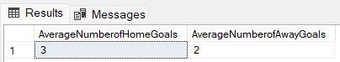

The home goals score on average one more goal than the away team.

1. **Times were home team won in 1880s.**



Around 50% matches the home team won in the 1880s.

**3b) Times were away teams won in 1880s.**



Around 40% matches the away team won.

1. **Most home winning teams in 1880s.**

Scotland was the most successful home winning team in 1880s, an extra four more than second place England.

**4b) Least home winning teams in 1880s.**

United States and Northen Ireland combined had the least home wins with 1 each.

**4c) Best away winning teams in 1880s**

Scotland won the most away matches, another three more than England.

**4d) Least away teams wins 1880s.**



Canada got the least away wins in the 1880s.

1. **Total home goals scored in 1880s.**

Scotland scored the most home goals , a seven more than England.

**5b) Least home goals scored in 1880s.**

United States scored the least home goals with the second team Northen Ireland managed to scored an extra twelve more than them.

1. **Highest away goals scored in 1880s.**

England and Scotland both scored the most away goals , so much they have 35 more than the second-place team.

**6b) Least away goals scored in 1880s.**

Canada scored the least away goals , with a close second is Northen Ireland how scored only five.

1. **Matches that ended in a draw in 1880s.**



Only 10% of matches ended in a draw in 1880s, showing there is a 90% chance of victories which is very high.

**7b) Team who drew the most at home in 1880s.**

England got the most draws at home in 1880s.

**7c) Team who drew the least at home in 1880s.**

Three national teams share the least draws , which suggests they had a confident playstyle at home.

1. **Team that drew the most as the opposing team in 1880s.**

Wales and Scotland both had the most away draws in 1880s.

**8b) Teams that drew the least as the opposing team in 1880s.**

England got the least away draws in 1880s.

1. **Teams that hosted tournaments in order in 1880s.**

England had the most tournaments, only one more joint second Ireland and Scotland.

**9b) Teams that hosted the least tournaments in 1880s.**

Wales hosted the least tournaments in 1880s, but is only two less than the most England, this suggest that everyone had a fair chance in hosting tournaments.

1. **Most home matches played in 1880s.**



England had the most home games played but only four more than fourth place Northen Ireland which indicates many national teams had the opportunity to play at home.

**10b) Least home matches played in 1880s.**



United States played the least games at home, potentially due most teams being British, the travel can be too much.

1. **Most away matches played in 1880s by teams.**



Wales played the most away games in the 1880s.

**11b) Least away matches played in 1880s per teams.**



Canada played the least away matches in 1880s.

1. **Matches played in a neutral venue.**

All matches played a national team had an advantage.

**Summary of 1880s data explorations**

In the 1880s, football had an expansion with 55 matches played which is a significant rise from the previous decade. Home team held a moderate advantage, winning approximately 50% of the matches, while away team managed victories in around 40% of the games. Scotland emerged once again excelled both home and away whilst United States and Northen Ireland struggled to secure wins.

Only around 10% of matches ended in a draw highlighting the likelihood of a clear winner in matches during period. England hosted the most tournaments but each national had a relatively fair chance in hosting a tournament as they are all shared out. England also topped the list of home games played, with United States playing the least. Wales and Canada stood out with the least matches played. This era signifies the home advantage and showcasing the evolving landscape of football and its reach to different continents.

**Results Dataset Next 59 rows - 1890 - 1899**

1. **Total matches played in the 1890s.**



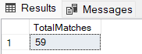

Only four more matches played in the 1890s.

1. **Average amount of goals scored both sides in 1890s.**

The home teams are more likely to score an extra goal than the average.

1. **Where home team won in 1890s.**



Around 50% of matches the home team won in the 1890s.

**3b) Where away won in 1890s.**



Around a third of matches the away team won in 1890s.

1. **The highest home winning team in 1890s.**

The England won the most home matches in the 1890s.

**4b) Least home winning team in 1890s.**

Northen Ireland and Wales both had the least home wins in 1890s.

1. **Best away winning team in 1890s.**

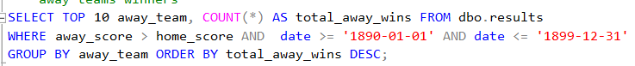

England won the highest number of away matches, three more than Scotland.

**5b) Least away winning team in 1890s.**

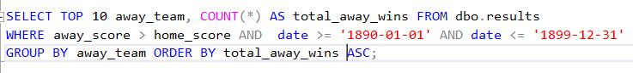

Northen Ireland won the least away matches with only one.

1. **Teams with the most home goals in 1890s.**

England scored the highest home goals, an extra fifteen more than Scotland in 1890s.

**6b) Teams with the least home goals in 1890s.**

United States scored only three goals at home, twelve less than Northen Ireland and thirty-six less than Wales, to signify how little number of goals they have scored.

1. **Most away goals scored in 1890s.**

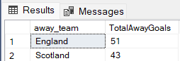

England scored the most away goals with a total number of 51, Scotland is second place with 43.

**7b) Least away goals scored in 1890s.**

Wales scored the least number of away goals, only one less from Northen Ireland.

1. **Matches that the game ended in a draw in 1890s.**



Around 15% of matches ended a draw in 1890s.

**8b) Total draws at home in 1890s.**

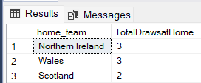

Northen Ireland and Wales drew the most home games , Scotland is a close second with 2 draws.

**8c) Least draws at home in 1890s.**

England had the least draws in 1890s.

1. **Most away draws in 1890s.**

Scotland and England have the joint most away draws in 1890s.

**9b) Least away draws in 1890s.**

Northen Ireland drew the least away from home in 1890s.

**8) Tournaments that was hosted by a country in 1890s.**

England hosted the most tournaments one more than Scotland.

**8b) Tournaments hosted the least amount by a country in 1890s.**

The least tournaments were hosted by Ireland and Wales and 1890s.

**9) Most home games played in 1890s.**



3 home team all played fifteen games played and are the highest number of it in the 1890s.

**9b) Least home games played in 1890s.**



Northen Ireland played the least home games , only one less than the highest.

1. **Most away games played in 1890s.**



3 national teams all played the most away matches in 1890s.

**10b) Least away games played in 1890s.**



Wales played the least away games but only one less than the joint highest.

1. **Number of non-neutral games played in 1890s.**

All matches a national team had an advantage in the 1890s.

**1890s data explorations**

The era showed the traditional home advantage, emphasizing on the importance of local support. England displayed dominance, winning both at home and away the highest. However, Northern Ireland and Wales faced difficulties in home victories, highlight support from crowd doesn’t dictate results. Moreover, England where the highest goal scored and outperforming opponents both home and away. United States face significant challenges in scoring goals at home, these trends showcased a variety of performance and dynamics among different national teams.

**Results Dataset 124 rows - 1900 - 1909**

1. **How many games that were played in the 1900s decade.**



This is the first decade of football were over a hundred of matches played in 1900s.

1. **On average goals scored from home and away matches in the 1900s decade.**

The home team is twice as likely to score than the away team.

1. **home team won in the 1900s decade.**



Only 45% of matches the home team won to which portrays their more loses and draws then other decades.

**3b) When away team won in the 1900s decade.**



35% of matches the away team won in 1900s.

1. **Teams with the most home wins in the 1900s decade**

England is the highest and the only team to win double digits at home.

**4b) Teams with the least home wins in the 1900s decade.**

5 national teams all won only one match at home.

1. **Teams with the most away wins in 1900s decade.**

England dominated this decade as they won fifteen away matches, second place Scotland only one six.

**5b) Least away wins for a team in 1900s decade.**

Hungary won only one matches as the away team, the least in this decade.

1. **Highest home goals scored in 1900s decade.**

Scotland scored the most home goals in 1900s, and Hungary scored only two less.

**6b) Least home goals scored in 1900s decade.**

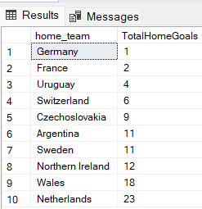

Germany scored only 1 home goals, the least in the decade.

1. **Most away goals scoring teams in order of 1900s decade.**

England scored the most away goals, fifty more goals than second place Scotland.

**7b) Least away goals scoring teams in order of 1900s decade.**

Switzerland as the opposing is the only team to not score an away goal in the decade.

1. **Matches that ended in a draw in 1900s in decade.**



Around 20% of matches that ended in a draw.

**8b) Matches ended in a draw in 1900s in decade.**

3 national teams had the highest draws at home, Wales, Hungary and England are the countries.

**8c) Least matches that ended in a draw in 1900s.**

Three national teams all drew the least at home this includes Argentina and Belgium.

1. **Away teams that drew the most in 1900s decade.**

Scotland drew the most away games, with England being a close second with four only one less.

**9b) Teams with the least draws away from home in 1900s decade.**

5 teams share the least amount of draws to which includes Hungary, Germany, France and Uruguay.

1. **Most tournaments hosted in 1900s decade.**

England hosted the most tournaments they pipped Ireland and Wales by 1.

**10b) least tournaments hosted in 1900s decade.**

Belgium hosted the least tournaments with only and two less than Uruguay.

1. **Most home games played in 1900s.**



England and Hungary both played the most home games in the first ten years of 1900s.

**11b) Least home games played in 1900s.**



Germany and Sweden both only played one home game in this period, but both made their debut.

**11c) Most away games played in 1900s.**



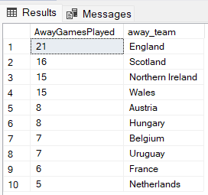

England played the most away games, five more than Scotland in 1900s.

**11d) Least away games played in 1900s.**



Norway played the least away games with only one match in the 1900s.

1. **Non-neutral matches 1900s.**



All matches were played at a neutral venue.

**1900s data exploration**

There was a surge of more matches with over a hundred, highlighting the growing interest in the sport. Home team enjoyed a notable advantage, scoring twice as then the away team, but there was a dip in their percent by 5%, indicating more losses and draws than previous decade. England were the front runners as they were victorious in the bulk of their home and away matches. Notably, Germany and Hungary faced challenges recording minimal wins and goal-scoring struggles. Draws were slightly more frequent, accounting for about 20% of matches with Wales, Hungary, England recording the highest number of home draws. Scotland led in away draws, emphasizing their resilience. Hosting tournaments became prevalent , with England leading in hosting, while Belgium hosted the least events. The decade portrays England dominance, fluctuations in home team advantage, varied hosting trends and portraying a landscape in football.

**Results Dataset 283 rows - 1910 - 1919**

1. **How many matches played in 1910s.**



Over double number of matches were played in the 1910s.

1. **A screenshot of a computer

   Description automatically generatedAverage number of goals scored both sides in 1910s.**

The home goals scored twice as more than away goals scored.

1. **Where home team won in 1910s.**



Only 50% of matches the home team won in 1910s.

**3b) Where away team won in 1910s.**



30% of matches the away team won in 1910s.

1. **Where home team won in total in 1910s.**

Argentina won the most at home with the only team with twenty or more wins.

**4b) Teams that won at home the least in 1910s.**

Four home team all won only once at home in the 1910s.

1. **Best away winning teams in 1910s.**

Hungary won the most as the opposing team, only won more than Argentina.

**5b) Least away winning teams in 1910s.**

6 national teams all won only once away from home, the top ten only has 3 away wins this decade.

1. **Most home goals scored by teams in order in 1910s.**

Argentina scores the highest home goals, but 5 teams managed to score sixty or more which shows the quality of football being played.

**6b) Least home goals scored by teams in order in 1910s.**

1. **Most away goals scored by teams in order in 1910s.**

Hungary scores the most away goals by twenty more than second place Argentina.

**7b) Least away goals scored by teams in order in 1910s.**

Luxembourg scored zero away goals in the 1910s

.

1. **Matches that ended in a draw in 1910s.**



Around 18% of matches ended in a draw which shows 82% of matches ended in a team winning.

**8b) Total home draws in 1910s.**

Argentina and Norway share the stat of drawing at home in 1910s.

**8c) Least home draws in 1910s.**

4 national teams all drew only once at home in the 1910s.

1. **Most away draws by teams in order in 1910s.**

Uruguay drew the most away matches , three twice more than tenth placed Basque Country.

**9b) Least away draws by teams in order in 1910s.**

7 national teams all drew only one away matches in 1910s.

1. **Teams who hosted the most tournaments in 1910s.**

Uruguay hosted the most tournaments , Argentina hosted only two less.

**10b) Teams with the least hosted tournaments in 1910s.**

England hosted the least tournaments in the 1910s, with joint seconds Brazil and Scotland**.**

1. **Home games played by teams top 10 in order in 1910s.**



Argentina played the most home games, only four more than Uruguay.

**11b) Least home games played by in order in 1910s.**



Japan played the least home games in 1910s.

**11c) Most away games played in 1910s by teams.**



Argentina also played the highest away games in 1910s.

**11d) Least away games played in 1910s by teams in order.**



Luxembourg and Philippines both played the least number of games in 1910s.

1. **Non-neutral matches in 1910s.**

All matches a national team played at home, so all were non-neutral venues.

**1910s data explorations summary**

This was a transformative decade of football with doubling the matches played, popularity increased. Home reams demonstrated clear dominance, scoring twice as many as the away team, reinforcing the influence of playing on a similar turf. Despite a 50% home victory rate, Argentina emerged as the front runner for home victories, whilst many struggled. Away victories were minimal with Hungary excelling as the most successful away team, and many nations with only one away win. Draws were around 18%, majority of matches decided by specific outcomes, Uruguay and Argentina led in tournaments hosting, highlight South America’s prominence and arrival to world football, while England and Scotland had fewer hosts that usual. Teams such as Japan and Philippines had minimal involvement due to geographical reasoning, overall, this decade continued home advantage, Argentina’s brilliance, and comfort on familiar pitches.

**Results Dataset 729 rows - 1920 – 1929**

1. **How many games were played in the 1920s.**



An Extra 446 matches were played in the 1920s.

1. **Average goals scored both sides in 1920s.**

The average home team scored double amount then the away team scored.

1. **Where home team won in 1920s.**



49% of home team won their game, nearly a one out of two chance the home team won.

**3b) where away team won in 1920s.**



Only 31% of chance the away team won.

1. **Home teams that won the most in 1920s.**

Argentina won the most home matches, four more than Sweden in 1920s.

**4b) Least home team wins in 1920s.**

All ten teams only won one home matches in 1920s.

1. **Away teams that won the most in 1920s.**

England won the most away matches but the list is tight with 1 win difference between the top 4.

**5b) least away teams winning matches in 1920s.**

10 away teams all won only once away from home.

1. **Most home goals scored in 1920s.**

Sweden scored the most home goals in 1920s, an extra forty more than the second-place team.

**6b) Least home goals scored in 1920s.**

Aruba is the only home team not to score at home in the 1920s.

1. **Most away goals scored in 1920s.**



Sweden scored the most away goals in 1920s, pipping England by 9 Goals.

**7b) Least away goals scored in 1920s.**

7 national teams failed to score away from home in 1920s.

1. **Where the match ended in a draw in 1920s.**



20% of the time the match ended as a draw in 1920s.

**8b) Home teams that drew the most in 1920s.**

Italy drew the most home matches, but three teams are joint second with only one less.

**8c) Least teams that drew at home in 1920s.**

All 10 teams all drew only once at home in 1920s.

1. **Away teams that drew the most in 1920s.**

Argentina drew the most away from home, pipping Austria and Netherlands.

**9b) least away draws by teams in 1920s.**

10 teams only drew once in 1920s.

1. **Countries that hosted the most tournaments in 1920s.**

Argentina hosted the most tournaments in 1920s, hosting twelve more than second place.

**10b) Least tournaments in countries in 1920s.**

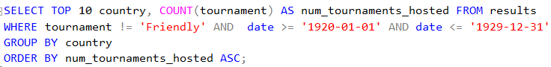

Romania hosted only one tournament in 1920s.

1. **Home games played the most in 1920s.**



Sweden played the most home games, pipping Argentina by only one**.**

**11b) least home games played in 1920s.**



All 10 national teams only played 1 home game in 1920s.

**11c) Most away games played in 1920s by teams.**



Sweden played the most away games in 1920s,only three more than second place Austria.

**11d) Least away games played in 1920s by teams,**



All 10 national teams all played won away games in 1920s.

1. **Non-neutral in matches in 1920s.**

All matches a team had the advantage in the 1920s.

**1920s data exploration summary**

1920s data exploration portrays several findings, starting with the surplus of matches compared to previous decades. Home teams notably dominated by scoring double the number of goals and showcasing the influence of familiar territory. Argentina and Sweden emerged as dominant forces at home, securing the most victories, while an unusual trend emerged with all ten teams managing only one home win each. England led in away victories by a slim margin, however parity was evident, with ten nations securing just one away win. Sweden stood out in goal-scoring, whilst Aruba failed to score at home. Draws were in the 20-percentile range with Italy leading in home draws. Argentina stood out in away draws, they also held the most tournaments and Romania the least. Each match was played on a home team ground and consistent home advantage in 1920s.

**Results Dataset Next 1010 rows - 1930 – 1939**

1. **How many games were played in the 1930s.**



There was a little over a thousand games played, meaning that it is the first decade were football has taken off globally.

**2) What is the average number of goals scored by home teams and away teams**



The home team are twice as likely to score than the away team this again is due to the home crowd supporting the team, potentially due to it being the first global decade of international matches there was little amount of away fans present.

**3) Games were home team won in 1930s.**



Again, a little over 50% of home team won meaning that they were the majority for obvious reasoning, and a third of matches were won by the away team.

**3b) Games were away team won in 1930s.**



Around a third of matches ended in the away team winning which a common them in football results.

1. A screenshot of a computer

   Description automatically generated**National team with most home wins in 1930s (Top 10)**

Germany was the most successful home team in this period as they won a total of 29 matches at home.

**4b) National team with least wins in 1930s.**

There are 10 joint teams with the least number of wins, potentially due to being a smaller number of matches than an international team such as England potentially financial and economic where factors included.

1. **Total Home goals scored in 1930s.**

Sweden have scored the most home goals in this period however they weren’t the most successful home teams this shows that scoring more goals doesn’t always equate to winning more matches.

**5b) Least Home goals scored in 1930s.**

There are 3 joint home teams that scored zero goals, this finding presents that all three teams were unsuccessful potentially due to not playing enough home matches or all their matches were against the top 10 team home goals scoring teams.

1. **Most away goals scored in 1930s.**



Germany have scored the most goals away from home, the only other team is Hungary that scored over a hundred goals.

**6b) least away goals scored in 1930s (bottom 10)**



Philippines is the only team to not score an away goal in the 1930s.

1. **Matches that ended in a draw in 1930s.**



A little over 10 percent of matches in the draw which highlights that there is a 90% chance of a winning teams, also football betting also started to take off in this period meaning that with this data picking a team to win is beneficial if betting.

**7b) Most home team draws in 1930s.**

Germany drew the most home games due playing more matches than the average national teams.

**7c) Least draws at home in 1930.**

There 10 national teams that were joint least drawing home which shows that they had a more offensive playstyle as they lost or won matches and only drew once.

1. **Most away draws in 1930s.**

Hungary have drawn the most away matches potentially due to playing the more matches they were in the top 3 of most goals scored away or home.

**8b) Least away draws in 1930s.**

There is joint 10 teams that drew away matches the least in the 1930s.

1. **Top 10 countries who hosted tournaments.**

Italy have hosted the most tournaments which benefited them as they were the second most home winning, this shows they have taken advantage of playing home matches.

**9b) Least 10 countries hosting tournaments.**

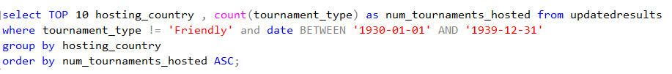

This is the list of the least 10 national teams that hosted a tournament, Germany despite hosting two tournaments never struggled throughout as they won the most home matches and scored the most home goals in this period and had a great away form.

1. **Top 10 countries playing home games in 1930s.**



Germany played the most home games which resulted in the most wins in the 1930s.

**10b) Top 10 least countries playing home games in 1930s.**



8 teams played the least home game in the 1930s which led to less wins at home due to not having the opportunity to play enough.

1. **Most Away games played in 1930s.**

Hungary played the most away games in this period however they still managed to score over a hundred goals as the opposing teams.

**11b) Least aways games played in 1930s.**



There are 6 teams who played the least away games potentially to economic factors that led to also less home matches.

1. **Played in a neutral venue or not.**



All matches played where a home teams hosted meaning that there was not a neutral venue, and a team had an advantage.

**1930s data exploration summary**

In the 1930s, football experience a global surge with over a thousand matches, marking its widespread in international growth. Home teams maintained a distinct advantages, largely due to home support and emerging era of international matches, likely in resulting to minimal away presence. Goals scoring patterns show Sweden to most home goals scored but never had the best home form but was the best away team in terms of victories. 90% of matches ended in a definite result which could be decisive in football betting as it became a rising trends in the 1930s.

**Results Dataset – 804 Rows – 1940-1949**

1. **The amount games played in the 1940s.**



A total of 804 matches where played, matches were put to a pause because events outside the national team’s control as there are at least 200 less games in this decade.

1. **The average number of home and away goals scored.**

The home team again is twice as likely to score as the opposition in the 1940s.

1. **Retrieve results were home team won in 1940s.**



Over 52% of matches the home team won showing on average the home team is likely to win.

**3b) Retrieve results were away teams won in 1940s.**



Over 30% matches were won by the away team showing that for betting purpose the opposing team had a decent chance to win.

1. **A screenshot of a table

   Description automatically generatedMost wins from national teams in 1940s**

Argentina is undoubtedly the best home team and majority of teams are in the continent of South America to which it shows due worldwide events led to them playing more matches than European national teams.

**4b) Least wins from national teams in 1940s.**

The least wins at home were 10 national teams all joint.

1. **Top 10 home goals scored by national teams in 1940s.**

Argentina dominated playing home games as they scored 149 goals to put it in perspective, the 10th most goals scoring team only got 50.

**5b) Least 10 home goals scored by national teams in the 1940s.**

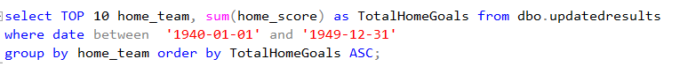

There are 4 national teams that scored zero goals at home in 1940s.

1. **Top 10 teams’ goals scored by national away from home.**



Uruguay ,82 away goals scored in 1940s to highlight their confident playstyle.

**6b) Least 10 teams goals scored by national teams.**



Out of the bottom 10 national away scoring team only Barbados managed to score, potentially to show the difficulty of playing away from home.

1. **Find the amount of draws in 1940s.**



Around 16% matches were drawn in the 1940s which shows it’s the most to the current date.

**7b) Find the team with most home draws in 1940s.**

Curacao drew the most home matches in 1940s.

**7c) Find the least home draws in 1940s.**

The least drawn is joint in the 1940s between 10 teams.

1. **Most away draws from home in 1940s.**

3 teams share the joint most away draws; all 3 findings are from various parts of the world.

**8b) Least away draws for national teams in 1940s.**

The least drawn is joint in the 1940s between 10 teams.

1. **National teams that hosted tournaments in 1940s**

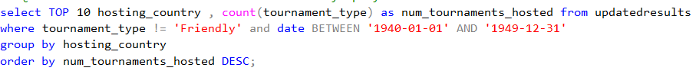

Brazil hosted the most tournaments in the 1940s by large amount to put it in to perspective, they hosted 29 more tournaments than the 10th country on the list.

**9b) Least hosted tournaments by national teams bottom 10 in 1940s.**

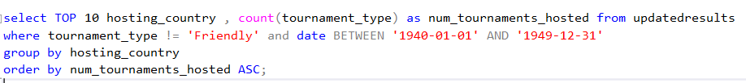

5 national teams hosted the least tournaments in this period.

1. **Home games played in 1940s by national teams.**



Argentina manages to play the most home games which they managed to win 33 out of 37 matches.

**10b) Least Home games played in 1940s by bottom 10 national teams.**



10 Teams only got play 1 match at home which could be due to assorted reasons outside their control.

1. **Most away games played in the 1940s by national teams.**

Uruguay played the most away game in this period.

**11b) Least away games played in the 1940s by national teams.**



10 national teams all played only 1 match away from home which could be an advantage however it could be due to external reasons.

1. **Games played in a neutral venue.**

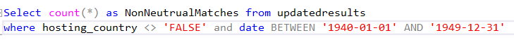

All matches a national team had the advantage.

**1940s data exploration summary**

1940s saw a total of 804, a decline in matches due to external events interrupting flow of matches. A consistent trend emerged with home teams dominating, scoring twice as many goals as the visiting teams, underscoring the home advantage. A balanced competition as a third of the matches the away team won, and the home team won half the matches displaying over three quarters there was a definite result.

Argentina emerged as a powerhouse, dominating home games and score 149 goals significantly surpassing other teams. Uruguay stood out in away games with 82 goals indicating their strong away playstyle. Draws were notably high, accounting for about 16% of matches, Brazil hosted significant more tournaments than any other country. Argentina played the most home games and winning 90% of matches, due to uncontrollable factors many teams only played one home match. This decade didn’t witness neutral venue games, and distinct home team advantage.

**Results Dataset – 1576 Rows – 1950-1959**

1. **Amount of national football matches played in the 1950s.**



This is the number of matches that were played in the 1950s.

1. **Home goals scored and away goals scored on average.**



The home team are twice as likely to score as likely as the away team.

1. **Home teams wins in 1950s.**



Around 48% of matches the home team won, which shows it’s the least amount of since international football started.

**3b) Away teams win in 1950s.**



A third of the matches the away team came out victorious in the 1950s.

1. **A screenshot of a computer

   Description automatically generatedSelect top 10 home teams winners in 1950s.**

Brazil undoubtedly was the best home team as the won the most matches by fourteen more.

**4b) Least 10 home teams win in 1950s.**

10 national teams all managed to win only 1 game in the 1950s.

1. **Top 10 teams with home goals scored in 1950s.**

Brazil also scored the most home goals which resulted in to the most wins in the 1950s.

**5b) Least 10 teams goals scored at homes in 1950s.**

4 teams managed to score zero goals at home in the 1950s.

1. **Top 10 national teams of away goals scored in 1950s.**

Hungary scored the most away goals, almost a hundred more than the 10th highest away goal scoring team Norway.

**6b) Least 10 national teams away goals scored in 1950s.**



7 national teams managed not to score a single goal away from home in the 1950s.

1. **Total draws in national football matches in 1950s**



20% of matches ended in a draw which shows that 1 out of 5 matches ended in a draw in the 1950s.

**7b) Top 10 national teams with the most draws in order (1950s)**

Three national teams managed to draw double digits matches.

**7c) Least 10 national teams with draws in the 1950s**

10 teams all managed to draw only 1 game at home in the 1950s.

1. **A screenshot of a computer

   Description automatically generatedTop 10 away with the most draws in 1950s.**

England got the most away draws in the 1950s.

**8b) Least 10 away teams with draws in 1950s**

10 away teams managed to get only 1 draw in this period in the 1950s.

1. **Top 10 countries that hosted the most tournaments in the 1950s.**

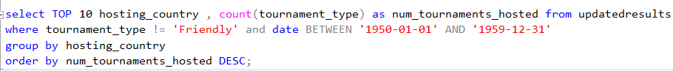

Sweden hosted the most tournaments in the 1950s, around thirty more matches than the 10th most in the 1950s.

**9b) Least 10 countries that hosted tournaments in 1950s.**



8 teams only hosted one tournament in the 1950s.

1. **Top 10 home games played in 1950s.**



Brazil played the most home games to which they benefited as they won the most home games, however Argentina has a better winning ratio.

**10b) Least 10 home games played in 1950s.**



10 national teams only got to play one home game in the 1950s.

1. **Top 10 teams that played games away from home in 1950s.**



Uruguay played the most away games to which can lead to a disadvantage as every other national team played less away games.

**11b) Least 10 teams that played away matches in 1950s.**



10 teams managed to play only one away game which can be an advantage as they played more home matches.

1. **Matches played in a non-neutral match.**



Every match a team had an advantage in the 1950s.

**1950s data exploration summary**

In the 1950s, a considerable number of football matches were played, revealing a noticeable trend where home team exhibited a clear advantage. Home teams scored twice as many goals on average then the away team to symbol the dominance of home ground. Brazil successfully was the best home winning team and scored the highest number of home goals to display their dominance. However, away wins were significant, with a third of matches resulting in victories for the visiting teams. Hungary stood out in away goal scoring and draws were also quite common in 1950, these scenarios competitive balance, influencing teams’ performance on a variety of factors.

**Results – 2810 rows – 1960 – 1969**

1. **Total matches played in 1960s.**



Almost double number of matches were played in the 1960s compared to the 1950s.

1. **Comparing the average number of goals home to away in the 1960s.**

Home team once again are likely to score twice as many as the away goals.

1. **Home team won the match in 1960s.**



Around 50% of matches the home team won which shows every other in the 1960s the home team have the chance win.

**3b) away team won the match in 1960s.**



Less than third of matches the away team won which highlights by 1960s, winning an away match was at its most difficult.

1. **Total home wins in 1960s**

Brazil once again dominated by winning the home wins in the 1960s.

**4b) Least 10 team with home wins in 1960s**

This is the 10 home teams that won only one match at home in the 1960s.

1. **Top 10 teams with the home teams scored in 1960s.**

Brazil scored the most home gaols however Indonesia managed to score only three less and is the highest goal tally.

**5b) Least 10 teams with home goals scored in 1960.**

3 national teams managed to score zero goals in the 1960s.

1. **Top 10 teams with most away goals scored in 1960s.**



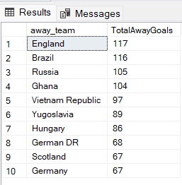

England were the front running away scoring goals in the 1960s.

**6b) Least 10 teams with away goals scored in 1960s.**

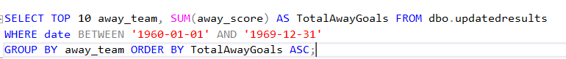

10 national teams scored zero away goals in the 1960s, this can be due to the difficulty of playing away from home.

1. **Total draws in the 1960s**



Exactly 20 per cent of matches were a draw which has been the theme to the current date(1960s)

**7b) Top 10 with total home draws in 1960s**

Malaysia had the most draws at home almost double the amount the 10th most(Brazil), potentially highlights there resilient to either sustain pressure or be able to do a comeback.

**7c) least 10 teams that drew in 1960s.**

10 teams only managed to draw one home game in the 1960s.

1. **Top 10 teams with the most draw away from home in 1960s**

Russia have drawn the most away games which indicates their ability to sustain pressure and maintain.

**8b) Least 10 teams that drew away from home in 1960s.**

10 teams drew only 1 match away from home, an offensive playstyle which led to a definite result(won/lost) in the 1960s.

1. **Top 10 teams that hosted the most tournaments in 1960s.**



Malaysia hosted hundred more than the second team on this list which shows the advantage they have had over competitors in matches.

**9b) Least 10 teams that hosted the most tournaments in 1960s.**

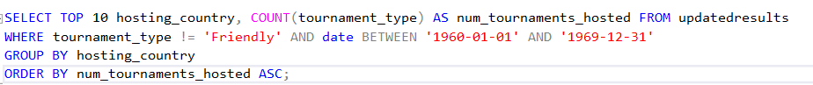

6 national teams only had 1 tournament they have hosted in the 1960s.

1. **Top 10 home games played in 1960s.**



Malaysia played the most home games in the 1960s.

**10b) Least 10 home games played in 1960s.**



8 national teams played only 1 home matches which can be disadvantageous or due to factors out of control.

1. **Top 10 teams that played away from home in 1960s.**



Russia have played the most away games in the 1960s.

**11b) Least 10 teams that played away from home in 1960s.**



10 teams only played one away game in the 1960s.

1. **Number of non-neutral matches played.**



All matches a single team had an advantage in 1960s because there wasn’t a neutral venue.

**1960s data exploration findings**

Once again nearly doubling of matches then previous decade, home team continued their dominance, translating into home advantage. Brazil and England emerged prominently, Brazil home wins were the highest, whilst England excelled in goal scoring. Draws remained in the 20-percentile range, Malaysia notably hosted the numerous tournaments showcasing their home advantage. Whilst several teams played a single home or away game. Non-neutral matches persisted throughout every game favoured a particular team, illustration absences of neutral venues.

**Results – 3924 rows – 1970-1979**

1. **Total matches played in the 1970s.**



Over an extra 1000s games were played in the 70s compared to the 80s.

1. **The amount of home and away goals scored on average in the 1970s.**



This is the first decade which the away team is as likely to score as the home team in the 1970s.

1. **Where home team won in the 1970s**



**50% of matches were won by the home team which is a common finding throughout the analysis of the results.**

**3b) Where away team won in the 1970s.**

A little under a third of the matches the away team won which again is common throughout.

1. **Total home wins for top 10 teams in 1970s**

South Korea has the highest amount of home wins in 1970s, this is also the most in a decade up to date.

**4b) Least 10 teams winning at home in 1970s.**

10 home teams only one matches to which majority are unsuccessful national teams for numerous factors.

1. **Top 10 total home goals scored in 1970s.**

South Korea dominated, first national team to score 200 goals or more at home in the 1970s.

**5b) Least 10 teams that scored at home in 1970s.**

8 national teams managed to score zero goals at home in the 1970s.

1. **Top 10 teams with the most away goals scored in 1970s.**



South Korea also scored the most away goals in the 1970s, which shows they have dominated this era offensively.

**6b) Least 10 teams with away goals scored in 1970s.**



For the first time, all bottom ten teams managed not to score an away goal in the 1970s.

1. **Total draws in the 1970s**

The highest total of draws to date to which is around 23% which shows nearly a quarter of matches were a draw in the 1970s.

**7b) Top 10 with home draws in order in 1970s**

Malaysia have drawn the most home games in 1970s.

**7c) Least 10 team with home draws in 1970s**

All 10 teams managed to draw 1 game to highlight it is the from the current findings it’s the most drawn decade of football.

1. **A screenshot of a computer

   Description automatically generatedTop 10 away teams with draws in 1970s**

Russia and Thailand both have the joint most draws away from home, also South Korea are third to signify they have dominated throughout and had minimal losses in this period.

**8b) Least 10 away teams with draws in 1970s**

10 national teams all managed to get 1 away draw in the 1970s.

1. **Top 10 countries that hosted the most tournaments in 1970s.**



Malysia hosted the most tournaments by over a hundred more than the second most in the 1970s.

**9b) Least 10 countries that hosted the tournaments in 1970s.**

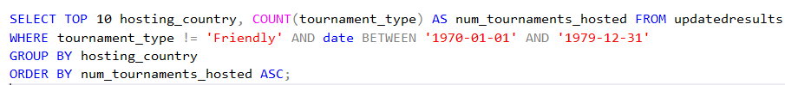

6 teams only managed to host one tournament in this period.

1. **Teams that played the most home games in 1970s**



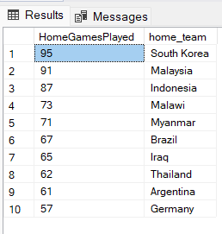

South Korea played the most home games which led to scoring the most goals.

**10b) Teams that played the least home games in 1970s.**

10 Teams all played 1 game at home, again due to factors.

1. **Most away games in 1970s**



Thailand played the most away games, the only team to play over a hundred matches in 1970s.

**11b) least away games played in 1970s.**



10 national teams all played 1 game away from home which can benefit them results based in the 1970s.

1. **Non-Neutral Matches in 1970s**



A team had an advantage there was not a neutral venue for any matches in the 1970s.

**1970s data exploration summary**

The 1970s marked a significant surge in matches played, exceeding 100 games more than the previous decade. It’s the first era the away team is equal to score a goal to the home team, and around half the victories the home team it was. A third of wins were away sides and a fifth of matches ended in a draw in the 1970s. South Korea emerged prominently, dominant with home win and goals, utilising the home crowd. Malaysia notably hosted the highest number of tournaments, non-neutral matches continued and the absence of venues.

**Results – 4797 rows – 1980 – 1989**

1. **Total number of matches playing in the 1980s**



Another extra 800 hundred more matches were played , football has now taken off globally and matches are being played more regularly.

1. **The average number goals scored home and away in 1980s.**



On average the home team is likely to score first and, in this decade, the away team went goalless on average.

1. **Where home teams won in 1980s**



This is the least amount a home team capitalized on their advantage, only 46% of home teams won their match.

**3b) Where away teams won in 1980s.**



28% percent of matches the away team have won in this period.

1. **Top 10 home winning team in 1980s.**

Once again South Korea have won the most home matches in the 1980s.

**4b) Least 10 home winning team in 1980s**

10 home teams all managed to win one game in this period.

1. **Total home goals scored (Top 10) in 1980s**



South Korea managed to score the most home goals which led to the most home wins.

**6b) Least home goals scored (bottom 10) in 1980s.**

7 national teams failed to score a single goal at home in the 1980s.

1. **Top 10 teams with the most away goal scored in the 1980s.**



Senegal scored the most away goals in the 1980s.

**6b) Least 10 teams with away goals scored in 1980s.**



6 national teams scored zero goals away from home in the 1980s.

1. **Matches that ended in a draw in 1980s.**



Around 27% of matches ended in a draw which is the highest tally, this supports the finding of the away team failing to score.

**7b) Top 10 teams with the most draws in 1980s.**

Malawi by over 10 draws got the most home draws in the 1980s.

**7c) Least 10 team that drew in 1980s.**

10 teams drew at home once in the 1980s.

1. **Top 10 with the most away draws in 1980s.**

Guinea drew the most games away from home.

**8b) least 10 teams that drew in 1980s.**

Once again ten teams managed to draw only 1 away game.

1. **Top 10 countries that hosted tournaments in 1980s.**



Malaysia again managed to host the most tournament in the 1980s.

**9b) least 10 countries that hosted tournaments in 1980s.**

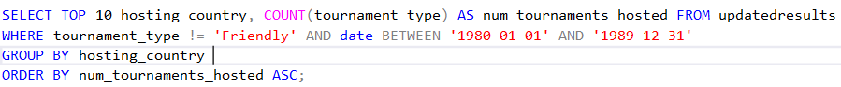

Three teams only managed to host 1 tournament in the 1980s, every other team got to host more.

1. **Top 10 teams with most home games played in 1980s.**



Malawi played the most home games in the 1980s.

**10b) Least 10 teams with home games played in 1980s.**



10 teams only got play one home game in the 1980s.

1. **Top 10 teams that played away from home in 1980s.**



Senegal played the most away games in the 1980s.

**11b) Least 10 teams that played away from home in 1980s.**



Seven teams played only game as the opposing team in the 1980s.

1. **Non-neutral matches played in 1980s.**

All matches played were favoured to a team as they had the home advantage in the 1980s.

**1980s data exploration summary**

An additional 800 matches were played compared to the 1970s, indicating a growing global interest in football. Home teams remained dominant, away teams won one in third. South Korea once again, dominating home wins and goals as they are front runners. A quarter of matches ended in a draw which is a record high since the start of international football, it gives a clear alternative to sports betting agencies as in the 80s there was a solid chance of a draw every 3 game. Malaysia continued the trend of hosting tournaments, while several teams played minimal home or away matches.

**Results – 6623 rows – 1990-1999**

1. **Total matches played in the 1990s.**



An extra 2000 matches were played in the 1990s, all over the world football is the go-to sport.

1. **What is the average number of home and away goals in 1990s?**



Both teams whether home and away on average can score in the 1990s.

1. **Where home team won in the 1990s**



Around 50% of matches played the home team won in the 1990s.

**3b) Where away team won in 1990s.**



Only a quarter of the matches the away team have won the matches, which is less than the last few decades.

1. **Total home wins in 1990s**

Brazil won the most home matches and were the winners of the world cup in 1994.

**4b) least home wins in 1990s**

All 10 teams managed to only win one home match.

1. **The most home goals scored in 1990s.**

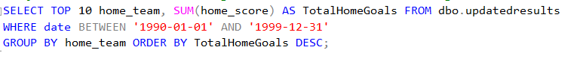

Brazil dominated as to date(1990s) scored the most home goals in one decade.

**5b) least home goals scored in 1990s.**



Only 1 team managed not to score at home in the 1990s.

1. **Top 10 away teams’ goals scored in 1990s.**

Russia scored the highest number of away goals in the 1990s.

**6b) Least 10 teams that scored away from home in the 1990s.**

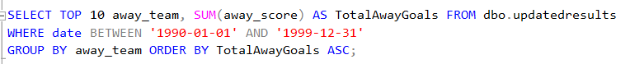

Only two teams failed to score as the opposing team in the 1990s.

1. **Matches that ended in a draw in 1990s.**



Around a quarter of the match managed to finish in a draw, to which it is equivalent to the away team winning for the first time, drawing is as likely as the away team winning in the 1990s.

**7b) Most home draws in 1990s.**

United States drew the highest amount in the 1990s.

**7c) least home draws in 1990s**

10 home teams only drew 1 game in this period.

1. **Top 10 teams with the most away draws in 1990s.**

Colombia drew the most away games, also the first time a top ten away drawing that is 21 draws which is usually the highest in previous decade.

**8b) least 10 teams drawing away from home in 1990s.**

10 national teams drew only one game, this indicates that chased a win, but some led to loses.

1. **Top 10 countries that hosted a tournament in 1990s.**

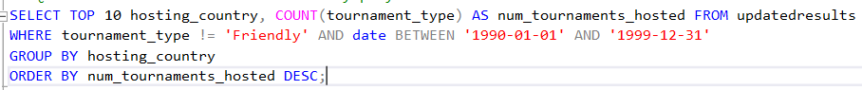

United States hosted over 150 tournaments in the 1950s , a hundred more than 10th place Jamacia.

**9b) least 10 teams that hosted a tournament in 1990s.**

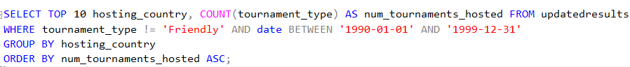

8 national team only hosted 1 tournament throughout the decade of the 1990s.

1. **Top 10 that played the most home games in 1990s.**



United States played the most home games in the 1990s, the only team with over a hundred home games played.

**10b) least 10 team that is played home games in 1990s.**



6 teams got only played 1 match to home throughout the whole decade.

1. **Most away games played in 1990s.**



Zambia played the most away games in the 1990s.

**11b) least 10 teams that played away games in 1990s.**



3 national teams played only 1 away game in the 1990s.

1. **Non-neutral matches in 1990s**

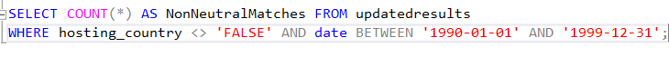

All matches were in favour of the home team, there was not a neutral venue.

**1990s data exploration summary**

With an extra 2000 games, football just kept getting more popular, marking a widespread appeal to football. A balanced decade, due home and away team scoring an equal amount per game. Home team victories remained dominant at around 50%, whilst away wins stood at a quarter which is an all time low in the 1900s.

Brazil showcased dominance, securing most home wins, and scoring the highest number of home goals. As a result, this helped them achieve the prestigious award of winning the World cup in 1994. However, a quarter of matches ended in a draw highlighting a similar playing field for both sides. Tournament hosting first place is United States including the World Cup 1994, and all played a

United States emerged prominently, hosting numerous tournaments, and playing the most home games, while some teams had minimal participation, playing only a single match either home or away throughout the decade. Non-neutral matches persisted, favouring the home team consistently.

**Results - 9459 rows- 2000-2009**

1. **Total matches played in 2000s.**



Highest total of matches played to date comparing to previous decade, a little under five figures.

1. **The average number of goals scored home and away in 2000s.**



The second decade in a row, the away team on average can score a goal like the home team.

1. **Where home team wins in the 2000s**



Around 50% of matches were played in the 2000s that the home team won.

**3b) Where away team wins in 2000s.**



Around 28% of matches ended in the away team being victorious.

1. **A screenshot of a computer

   Description automatically generatedThe top 10 team with the most home wins**

Mexico won the most home matches in this period, United States and Saudi Arabia were close and are runner ups.

**4b) least 10 home team wins**

All 10 managed to only win 1 home game in the 2000s.

1. **Top 10 with the most home goals scored.**

Like winning the most home matches , Mexico also scored the most home goals in the 2000s.

**5b) least 10 home teams goals scored.**

7 national teams managed not score at all at home which is the most in a decade.

1. **Top 10 teams with the most away goals scored.**



Brazil were the best away goals scorers in the 2000s.

**6b) Least 10 teams with the least away goals scored.**

4 national teams failed to score an away goal in 2000s.

1. **The amount of draws in the 2000s.**



A quarter of the matches ended in a draw meaning that , the away team winning or a draw happening is as likely.

**7b) The top 10 teams with the most draws in 2000s.**

Japan drew the most at home, whilst South Korea and Qatar being honourable mentions in the 2000s.

**7c) The least 10 teams with the least draws in 2000s**

10 teams all drew only once at home which suggests they had an offensive playstyle which led to more wins or loses.

1. **Top 10 with the most away draws in 2000s.**

Iraq and Paraguay drew the most at away from home in the 2000s to which highlights they resiliency to sustain constant pressure or have the momentum to do a comeback.

**8b) Least 10 with the least away draws in 2000s.**

10 teams all drew away once in the 2000s.

1. **Top 10 countries who hosted a tournament in 2000s.**



United States hosted the most tournaments in the 2000s a hundred more than Kuwait(10th place)

**9b) Least 10 countries who hosted a tournament in 2000s.**

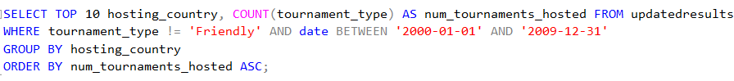

Only Dominica managed to host two tournaments the rest only were responsible for one tournament.

1. **Top 10 home teams played in 2000s.**



Mexico played the most home games, also it’s the highest amount of home games played as the majority of the top ten played over a hundred matches as the home team.

**10b) Least 10 home matches played in 2000s by teams.**



All 10 team only got play 1 home match in the 2000s.

1. **Top 10 away games played in 2000s by teams.**



Iraq played the most away matches but the whole top ten played a high number of away matches.

**11b) Least 10 away games played in 2000s by teams.**



3 teams played only 1 match away games and had the home advantage for most matches.

1. **Non-neutral matches in 2000s**



All matches a national teams had the advantage in the match.

**Summary of 2000s data explorations**

The number of football matches increased in the 2000s compared to earlier decades, and the home team continued to have a significant edge, winning about half of the games. On the other hand, the percentage of away wins rose little to about 28%. Mexico became a dominant force, topping the table in terms of goals scored both at home and abroad. Brazil was the best at scoring goals on the road, while South Korea and Japan often drew at home. About 25% of the matches were draws, indicating a balanced level of competition. Notably, Iraq and Paraguay frequently pulled away from home. Football events were held more frequently in the United States, which hosted the most tournaments. Many teams, most notably Mexico, participated in many games, stressing the need of a reliable home performance. On the other hand, a few teams saw very little home or away action. There were no neutral grounds, and matches were always biassed in favour of the home team over the ten years.

**Results – 9794 rows – 2010-2019**

1. **Total matches played in the 2010s.**



This is the most matches played in a decade since international football has started.

1. **The amount of home and away goals scored on average in 2010s.**



Both teams on average can score as both are 1 in this finding.

1. **Where home team won in 2010s**



Only a 47% chance of winning at home which is the second lowest toll for a home team since the start of international football.

**3b) Where away teams won in 2010s.**



A 28% chance that the away team can win, which has been a similar outcome.

1. **Top 10 teams with the most home wins in the 2010s**

Mexico won the most home matches in the 2010s , United States and Egypt are honourable mentions as they are only a few wins behind.

**4b) Least 10 home teams win in 2010s.**

All 10 teams all only won 1 match in the 2010s.

**4c) top 10 away teams’ winners in 2010s**

Spain won the most away matches in this period including winning the World Cup in 2010.

**4d) Least 10 away teams’ winners in 2010s**

All 10 teams managed to win only 1 away match in 2010s.

1. **Top 10 home goals scored in 2010s.**

Japan pipped Germany with the most goals in the decade, the whole ten teams all scored a huge amount and would have been top if it was an earlier decade.

**5b) Least 10 home goals scored in 2010s.**

Three teams weren’t managed to score a home goal in the 2010s.

1. **Top 10 teams with the most away goals scored in 2010s.**

Germany scored the most away goals, close by was Spain and Brazil, bar Belgium all other nine teams scored over 100 away goals in the 2010s.

**6b) Least 10 teams with the most away goals scored in 2010s.**

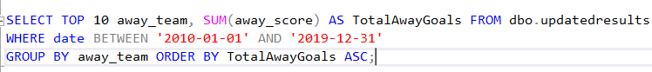

6 teams failed to score a goal in the 2010s.

1. **Total home draws in 2010s**



Around a quarter of matches ended in a draw in the 2010s.

**7b) Top 10 teams with the most draws at home in 2010s.**

South Africa drew the most home matches , followed by Zambia in the 2010s.

**7c) Least 10 teams with the least draws at home in 2010s**

10 teams all drew once at home in the 2010s.

1. **Top 10 away teams that drew in 2010s.**

Cameroon drew the most away games in the 2010s.

**8b) Least 10 away teams that drew in 2010s.**

10 teams all drew only one game away from home in the 2010s.

1. **Top 10 countries hosting the most tournaments in 2010s.**

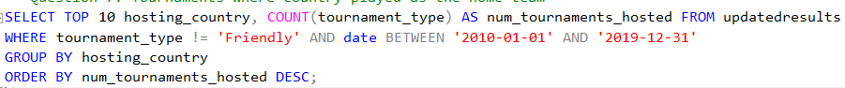

South Africa hosted the most tournaments in the 2010s mainly due to the World Cup to which covered a lot of matches.

**9b) Least 10 countries hosting tournaments in 2010s.**

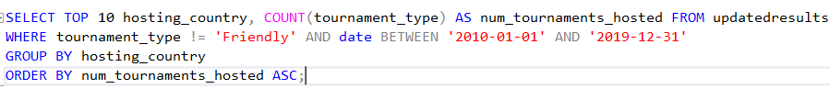

Three teams all hosted 1 tournament in the 2010s, all other countries got to do it at least twice or more.

1. **Top 10 home games played in 2010s.**



United States played the most home games , closely after is Mexico in the 2010s.

**10b) Least 10 home games played in by countries in 2010s.**



Apart from Matabeleland all other countries only played at home once in 2010s.

1. **Top 10 away games played in by nations in 2010s.**

Costa Rica played the most away matches in the 2010s.

**11b) Least 10 away games played by national teams in 2010s.**



8 teams got favoured and played only 1 away match, this can positively improve their home results.

1. **Non-neutral matches in 2010s**



All matches a team had the home advantage in the 2010s.

**Summary of 2010s data exploration**

With the most matches ever played, the 2010s were the busiest decade in international football history. Remarkably, home teams won about 47% of games, a significantly lower percentage of victories than in prior decades, while away teams continued to win about 28%. Mexico won the greatest number of games played at home, while Spain won the most games played away, including the 2010 World Cup. Germany and Japan both shown outstanding goal-scoring abilities at home. In the meantime, Germany led the way in goals scored away from home, closely followed by Brazil and Spain. About 25% of the games were drawn, with South Africa and Zambia having the most home draws. The most away games were drawn by Cameroon. Due in large part to the World Cup, South Africa hosted the most tournaments, but some countries had few opportunities to hold competitions that exhibit an unequal distribution. Some countries tended to play their home games or their away games, indicating tactical advantages in their schedules. Due to a dearth of neutral locations, home advantage persisted throughout the decade.

**Results – 3255 rows – 2020-2023**

1. **Total matches that were played in 2020s.**



This is the most matches played in only 4 years in the 2020s.

1. **The amount of home and away goals scored on average in the 2020s.**



The away team once again are likely to score on average as much as the home in the 2020s.

1. **Where home team won in the 2020s**



Around 48% of matches the home team won which is a common theme in the few previous decades.

**3b) Where away team won in the 2020s.**



30 percent of matches ended in the away being victorious in the 2020s.

1. **Top 10 with the most home wins in 2020s**

United States so far are most successful home team as they won the most matches.

**4b) Least 10 home wins in 2020s**

10 teams only won 1 game at home in the 2020s.

**4c) Top 10 away winning matches in 2020s**

Algeria so far have won the most away games, but this list is likely to change soon due to 10th place only having 2 less away wins.

**4d) Least 10 away winning teams in 2020s**

Least 10 teams all managed to win 1 away match in the 2020s so far.

1. **Top 10 home teams with the most home goals in 2020s**



United States comfortably scored the most goals as second place scored over 20 less.

**5b) Least 10 home teams with the least home goals in 2020s**

Apart from Yoruba Nation, the other nine teams failed to score in the 2020s.

1. **Top 10 away teams with the most goals in 2020s**

Canada scored the most away goals in the 2020s, they have scored an extra thirteen over second place.

**6b) Least 10 away teams goals scored in 2020s.**

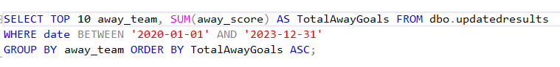

Froya and Mauritius both failed to score an away goal in 2020s.

1. **Matches that were draws in 2020s.**



Around 23% matches have ended in a draw which is a little lower than the last few decades meaning that more matches ended in a definite result.

**7b) Most home matches draw in 2020s.**

Mexico have drawn the most home games in the 2020s.

**7c) Least 10 home teams that drew in 2020s.**

All ten teams only drew one game at home, highlighting the confidence the teams have to play their chosen playstyle.

1. **Top 10 away teams with the most draws in 2020s.**

5 teams all are joint with the most away draws, however this list likely to change as the decade continues as the 10th place team have only 2 less draws.

**8b) Least 10 away teams that drew in 2020s.**

All teams have drawn once in this decade in 2020s.

1. **Top 10 countries that hosted the most tournaments in 2020s.**

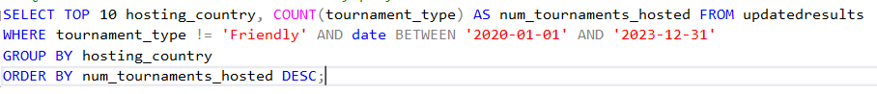

Qatar hosted the most tournaments in the 2020s because they hosted the 2022 World Cup.

**9b) Least 10 countries that hosted tournaments in 2020s.**

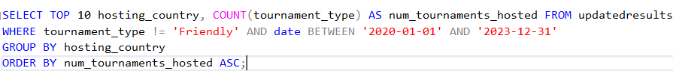

10 countries all hosted 1 tournament in this decade so far which is likely to change as the decade continues.

1. **Top 10 home games played in 2020s.**



Mexico pipped United States by one and they have played the most home games in the last few years.

**10b) Least 10 home games played in 2020s.**



All teams on this list played only 1 home games which is likely to change as another 6 years is set to go.

1. **Top 10 away teams’ games played in 2020s.**



Panama have so far played the most away games, but Iceland could overtake in the future.

**11b) Least 10 away teams games played in 2020s.**



All ten teams only played one away match in four years.

1. **Non-neutral matches played in 2020s.**

*****

All matches played were not a neutral venue and a team had an advantage.

**Summary of 2020s data exploration so far**

Football matches are played more frequently in the first part of the 2020s, and home and away goal averages are balanced. As in the past, home team triumphs average roughly 48%, while away team victories somewhat increase to 30%. In terms of wins at home and away, respectively, the United States and Algeria stand out as formidable competitors. There are noticeable scoring differences; Yoruba Nation, for example, has not yet scored a goal at home. Drawn match percentage drops to 23%, suggesting a shift towards more clear-cut results. Qatar is the best at hosting the 2022 World Cup. Teams display differing numbers of matches played; Mexico and Panama are the most active. There are still no impartial sites, which confirms home advantage's dominance.

**All time results from 1872-2023 findings**

1. **Total matches played in international football.**



The list of matches played since the start of international football.

1. **What is the average number of home and away goal scored in international football?**



An average of all time both teams scoring per game.

1. **Where home team won in international football matches?**



49% of matches the home team won of all time, the home advantage is proven by this finding.

**3b) Where away team won in international football matches?**



28% of matches the away team have of all time**.**

1. **Top 10 most successful home teams of all time in international football?**

Brazil is the most dominant home winning team of all time to which Argentia is an honourable mention.

**4b) Least 10 successful home teams of all time in international football?**

There is a joint least successful home winning teams to which is 10 national teams.

1. **Top 10 most successful away teams of all time in international football?**

England of all time is the most successful away winning team to which they have almost thirty more victories than second place Germany.

**5b) Least 10 successful international football teams of all time away from home**

There is a joint least successful away winning teams to which is 10 national teams.

1. **Top 10 teams with the most home goals scored of all time?**

Brazil scored the most home goals and easily over a hundred more than second place Germany.

**6b) Least 10 home goal scoring teams of all time?**

7 national teams failed to score a home goal of all time.

1. **Top 10 teams with the most away goals scored of all time?**

England have scored the most away goals of all time by a clear margin so much there are the only team with more than 1000 goals.

**7b) Top 10 teams with the least away goals scored of all time?**

A joint four national teams scored zero goals away from home of all time.

1. **How many draws of all time in international teams?**



23% of matches ended in a draw of all time.

**8b) Top 10 home teams that drew at home of all time?**

Mexico pipped Argentina by five to have drawn the most home games of all time.

**8c) Least 10 home teams that drew at home of all time?**

10 national teams sharing being the least drawn home teams of all time.

1. **Top 10 away teams that who drew away from home?**

England have recorded the most away draws of all time , to which Argentina and Uruguay are joint second.

**9b) Least 10 drawing away teams of all time in international football?**

10 national teams sharing having the least away draws of all time.

1. **Top 10 teams that hosted the most tournaments of all time in international football.**

Malaysia hosted the most tournaments since international football started whilst United State being a close second, the rest of the other countries theirs at least a two hundred between third.

**10b) Least 10 teams that hosted the tournaments of all time in international football?** 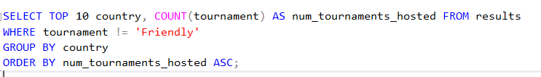

6 teams all share hosting the least amount of not tournaments in international football.

1. **Top 10 teams who played the most home games of all time in international football?**

Brazil managed to play exactly 600 home games which is the most in international football and Argentina being the runner up with 580.

**11b) Least 10 teams who played home games of all time in international football?**

10 national teams all played only 1 home game of all time, potentially a change of name or terminating from international football.

**11c) Top 10 teams who played matches as the opposing team of all time in international football?**

Uruguay have played the most away matches of all time.

**11d) Least 10 teams who played matches as the opposing team of all time in international football?**

10 national teams all have the least away games of all time , potentially due other factors causing it.

1. **Matches played in a non-neutral match of all time in international football.**

All matches played there was a home advantage for a team in international football.

**All time data exploration of international football results**

Several themes appear from the long history of international football, which spans from its inception to the present. Numerous matches have taken place over the years, demonstrating the sport's growth and international appeal. The trend in average scoring for home and away teams is still balanced, with a significant home advantage seen in 49% of home victories vs 28% for away teams.

Brazil is the most dominant squad at home, while England is the best away team in the world, having had unmatched success playing abroad. Brazil is the clear leader in goals scored at home, while England leads the world in goals scored away. Twenty-three percent of games are drawn, which indicates that teams are in a state of equilibrium competition.

Mexico, who always do well at home, comes out as the team with the most drawn home games. England leads the table in away draws, demonstrating their adaptability in a variety of settings. The number of tournaments held by the host countries varies; Malaysia has hosted the most, highlighting their historical importance in international football competitions.

Brazil and Uruguay, who have played in the most home and away games, respectively, have demonstrated their devotion to the game. Still, a few of countries have notably participated in very few games, suggesting that there may be organisational or participation issues.

The frequency of games that aren't neutral highlights the advantage that home teams have had throughout football history. Together, these results highlight how dynamic the game is, highlighting different team dynamics, historical supremacy, and the lasting impact of home field advantage in international football. The data on international football tells a story of perseverance, strength, and tough competition.

**Research Ethics Screening Form for Students**

Middlesex University is concerned with protecting the rights, health, safety, dignity, and privacy of its research participants. It is also concerned with protecting the health, safety, rights, and academic freedom of its students and with safeguarding its own reputation for conducting high quality, ethical research.

*This Research Ethics Screening Form will enable students to self-assess and determine whether the research requires ethical review and approval via the Middlesex Online Research Ethics (MORE) form before commencing the study. Supervisors must approve this form after consultation with students.*

|  |  |  |
| --- | --- | --- |
| Student Name: | Abdullahi Mohamed | Email: am3630@live.mdx.ac.uk |
| Research project title: | Data Analysis on International Football Results Over the Last 150 Years and Predicting Future Footballing Results Through Machine Learning | |
| Programme of study/module: | Information Technology Bsc | |
| Supervisor Name: | Carl James-Reynolds | Email: c.james-reynolds@mdx.ac.uk |

|  |  |  |
| --- | --- | --- |
| *Please answer whether your research/study involves any of the following given below:* | | |
| 1. HANIMALS or animal parts. | Yes | No |
| 1. MCELL LINES (established and commercially available cells - biological research). | Yes | No |
| 1. HCELL CULTURE (Primary: from animal/human cells- biological research). | Yes | No |
| 1. HCLINICAL Audits or Assessments (e.g. in medical settings). | Yes | No |
| 1. XCONFLICT of INTEREST or lack of IMPARTIALITY.   If unsure see “Code of Practice for Research” (Sec 3.5) at:   https://unihub.mdx.ac.uk/study/spotlights/types/research-at-middlesex/research-ethics | Yes | No |
| 1. XDATA to be used that is not freely available (e.g. secondary data needing permission for access or use). | Yes | No |
| 1. XDAMAGE (e.g., to precious artefacts or to the environment) or present a significant risk to society). | Yes | No |
| 1. XEXTERNAL ORGANISATION – research carried out within an external organisation or your reseach is commissioned by a government (or government body). | Yes | No |
| 1. MFIELDWORK (e.g biological research, ethnography studies). | Yes | No |
| 1. HGENETICALLTY MODIFIED ORGANISMS (GMOs) (biological research). | Yes | No |
| 1. HGENE THERAPY includes DNA sequenced data (biological research). | Yes | No |
| 1. MHUMAN PARTICIPANTS – ANONYMOUS Questionnaires (participants not identified or identifiable). | Yes | No |
| 1. XHUMAN PARTICIPANTS – IDENTIFIABLE (participants are identified or can be identified):  survey questionnaire/ INTERVIEWS / focus groups / experiments / observation studies. | Yes | No |
| 1. HHUMAN TISSUE (e.g., human relevant material, e.g., blood, saliva, urine, breast milk, faecal material). | Yes | No |
| 1. HILLEGAL/HARMFUL activities research (e.g., development of technology intended to be used in an illegal/harmful context or to breach security systems, searching the internet for information on highly sensitive topics such as child and extreme pornography, terrorism, use of the DARK WEB, research harmful to national security). | Yes | No |
| 1. XPERMISSION is required to access premises or research participants. | Yes | No |
| 1. XPERSONAL DATA PROCESSING (Any activity with data that can directly or indirectly identify a living person).  For example data gathered from interviews, databases, digital devices such as mobile phones, social media or internet platforms or apps with or without individuals'/owners' knowledge or consent, and/or could lead to individuals/owners being IDENTIFIED or SPECIAL CATEGORY DATA  (GDPR1) or CRIMINAL OFFENCE DATA.   1Special category data (GDPR- Art.9):” personal data revealing racial or ethnic origin, political opinions, religious or philosophical beliefs, or trade union membership, and the processing of genetic data, biometric data for the purpose of uniquely identifying a natural person, data concerning health or data concerning a natural person’s sex life or sexual orientation”. | Yes | No |
| 1. XPUBLIC WORKS DOCTORATES: Evidence of permission is required for use of works/artifacts (that are protected by Intellectual Property (IP) Rights, e.g. copyright, design right) in a doctoral critical commentary when the IP in the work/artifactis jointly prepared/produced or is owned by another body | Yes | No |
| 1. HRISK OF PHYSICAL OR PSYCHOLOGICAL HARM (e.g., TRAVEL to dangerous places in your own country or in a foreign country (see <https://www.gov.uk/foreign-travel-advice>), research with NGOs/humanitarian groups in conflict/dangerous zones, development of technology/agent/chemical that may be harmful to others,  any other foreseeable dangerous risks). | Yes | No |
| 1. XSECURITY CLEARANCE – required for research. | Yes | No |
| 1. XSENSITIVE TOPICS (e.g., anything deeply personal and distressing, taboo, intrusive, stigmatising, sexual in nature, potentially dangerous, etc). | Yes | No |

 M – Minimal Risk;         X – More than Minimal Risk.    H – High Risk

If you have answered 'Yes' to ANY of the items in the table, your application REQUIRES ethical review and approval using the MOREform **BEFORE commencing your research**. Please apply for ethical  approval using the MOREform (<https://moreform.mdx.ac.uk/>). Consult your supervisor for guidance. Also see *Middlesex Online Research Ethics (*MyLearning area*) and* [*www.tiny.cc/mdx-ethics*](http://www.tiny.cc/mdx-ethics)   
(CS students).

If you have answered 'No' to ALL the items in the table, your application is Low Risk, and you may NOT require ethical review and approval using the MOREform before commencing your research. Your research supervisor will confirm this below.

 Student Signature: Abdullahi            Date: 12/12/2023

**To be completed by the supervisor:**

|  |  |
| --- | --- |
| *Based on the details provided in the self-assesment form, I confirm that:* | Insert Y or N |
| The study is Low Risk and *does not require* ethical review & approval using the MOREform | y |
| The study *requires* ethical review and approval using the MOREform. | n |

 Superivsor Signature:C James-Reynolds Date14/12/23

**References**

**Article**

John Goddard., & Ioannis Asimakopoulos (2004). Forecasting football results and the efficiency of fixed odds betting. Wiley online library, 21(1),51-66, <https://onlinelibrary.wiley.com/doi/10.1002/for.877>

Rahul Baboota & Harleen Kaur (2019), Predictive analysis and modelling football results using machine learning approach for English Premier League, Science Direct, 35(2), 741-755, <https://www.sciencedirect.com/science/article/abs/pii/S0169207018300116>

### Tsuneshi Obata & Shizue Izumi (2022), Analysis and visualisations of team performances of football games, Data science: Present and Future, 5, 885- 898, <https://link.springer.com/article/10.1007/s42081-022-00173-z>

Roberto Gásquez & Vicente Royuela (2016), The Determinants of International Football Success: A Panel Data Analysis of the Elo Rating, Wiley online library, 97(2), 125-141, <https://onlinelibrary.wiley.com/doi/full/10.1111/ssqu.12262#ssqu12262-note-0029>

Fatima Rodrigues & Angelino Pinto (2022),Prediction of football match results using Machine Learning, Science Direct, 204(202), 463-470, [https://www.sciencedirect.com/science/article/pii/ S1877050922007955](https://www.sciencedirect.com/science/article/pii/%20S1877050922007955)

Johannes Stubinger & Benedikt Mangold & Julian Knoll (2019), Machine Learning in football betting: Prediction of match results based on player characteristics, 10(1), 44 -45, <https://www.mdpi.com/2076-3417/10/1/46>

Tanvir Alam & Jassim Almulla (2020), Machine Learning models reveals key performances metrics of football players to win match in Qatar star league, Page 213695 – 213705 <https://ieeexplore.ieee.org/abstract/document/9261335>

# Miguel-Angel Gomez (2020), Exploring elite soccer teams’ performances during different match-status periods of close matches’ comebacks, Science Direct, 132(1),

<https://www.sciencedirect.com/science/article/abs/pii/S0960077919305235>

Poojan Thakkar & Manan Shah (2021), An assessment of football through the lens of Data Science, Springer Link, 8, 823-836, <https://link.springer.com/article/10.1007/s40745-021-00323-2>,

**Conference**

Zulkifli Mohamad, Data Visualization of Football Performance Preceded to the Goal Scored, in K. Imran, innovation and technology in sports, (pp. 57-74). Springer: <https://link.springer.com/chapter/10.1007/978-981-99-0297-2_6>

Imran Sainan (2023), Data visualization of football using degree cardinality, Innovation, and technology in sports, (pp. 75-93). Springer: <https://link.springer.com/chapter/10.1007/978-981-99-0297-2_7>

Harry Elkins (2017), Implementing data analytics for football, in system & information, IEEE Xplore, IEEE:

<https://ieeexplore.ieee.org/abstract/document/7937717>

Che Mohamad Firdaus Che Mohd Rosli et al 2018 J. Phys.: Conf. Ser. **1020** 012003 <https://iopscience.iop.org/article/10.1088/1742-6596/1020/1/012003/meta>

[Victor Chazan Pantzalis](https://ieeexplore.ieee.org/author/37088577444) & [Christos Tjortjis](https://ieeexplore.ieee.org/author/37282666900) (2020), Sports analytics for football leagues table and player performance predictions, IEEE Xplore, IEEE: <https://ieeexplore.ieee.org/abstract/document/9284352>

Mansoor Alam (2020), A Data Science Approach to football collaborator section. IEEE Xplore, IEEE: <https://ieeexplore.ieee.org/abstract/document/9208331>

**Website**

Kaggle (2023), international football results from 1872 to 2023, available from data card at: <https://www.kaggle.com/datasets/martj42/international-football-results-from-1872-to-2017> ![date accessed 18th October 2023]

Microsoft. (2023), Microsoft Excel, available from Microsoft: <https://www.microsoft.com/en-gb/microsoft-365/excel> ![date accessed 28th October 2023]

MySQL. (2023), MySQL, available from MySQL: [https://www.thesql.com/](https://www.mysql.com/) ![date accessed 29th October 2023]

[Jupyter. (2023), Jupyter Notebook, available from Jupyter at: https://jupyter.org/](https://jupyter.org/) ![date accessed 29th October 2023]